https://play.google.com/store/apps/details?id=com.base6aa6d7b75c97c089d036381c.app

Money Helper
By rowgar
Checked by Neil Steven R.

Google Playstore
- change the app logo - do not show whites
- change wallpaper to HD image
- change the screenshots if changes are made

https://play.google.com/store/apps/details?id=com.base6aa6d7b75c97c089d036381c.app
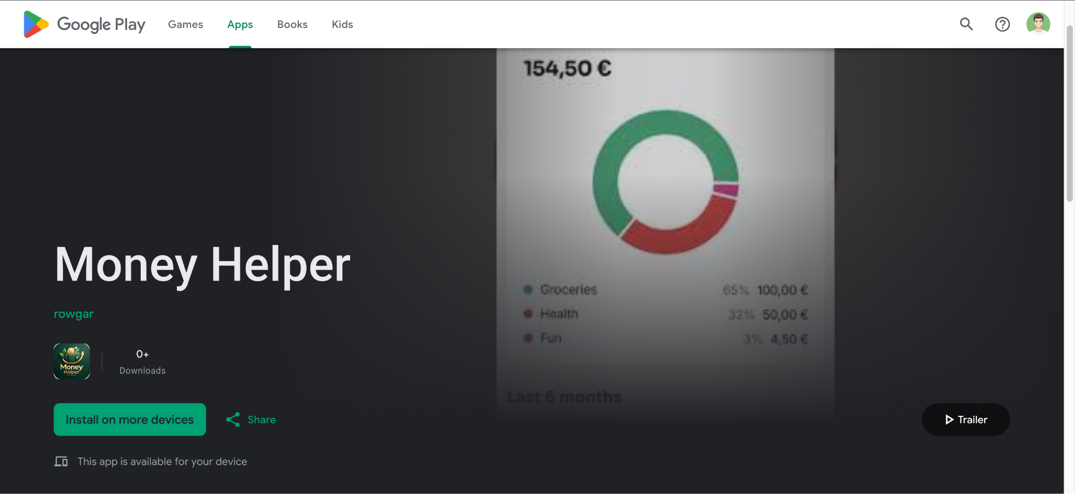
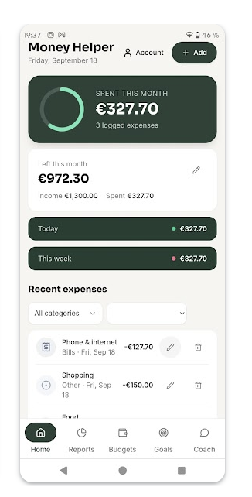

Change the app logo
- make sure to fill all sides, so users won’t see the whites.
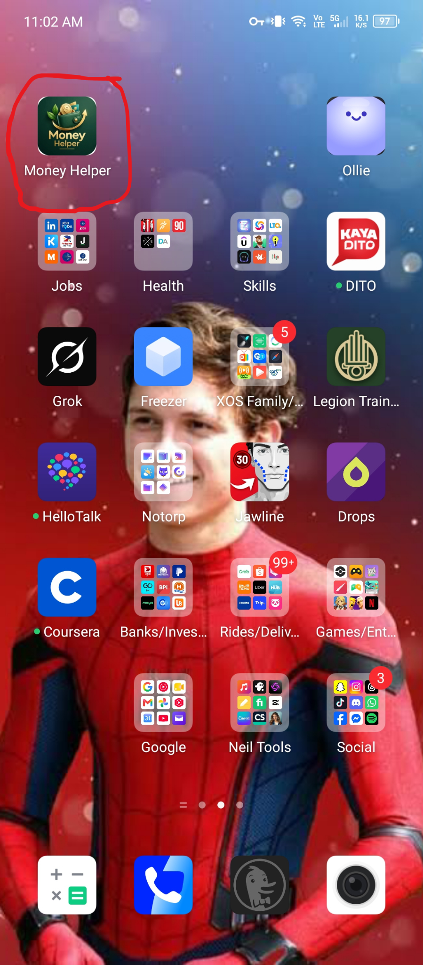

Signup / Login
- Change the password minimum to 12 characters or 15. (Old password rule is no longer considered: must include special symbol, capital letter and numbers)
- Change the alert text box to lighter red color. Try #FC0303
- Add show password icon/eye icon (allow the user to take a peak if passwords match)

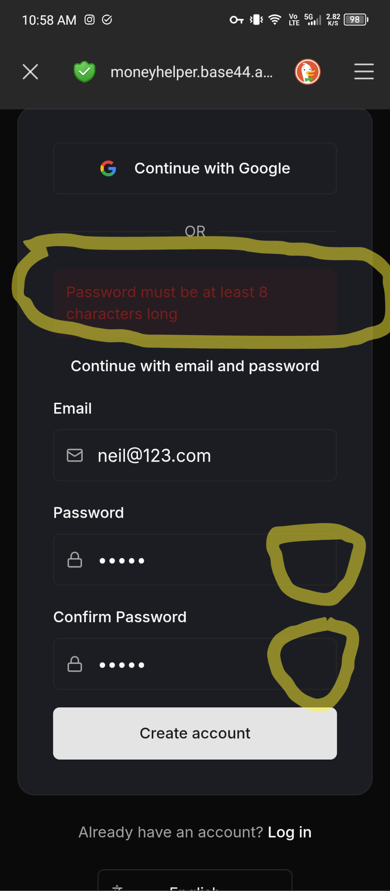

Home / App Dashboard
- the app is not being utilized, it opens my duckduckgo browser instead (i used Google login)
- change “Money Helper” to app logo
- change “Account” to user first name (Neil Steven)
- money spending circle - does not go full, should change to red or #FC0303
- enable overflow for money spent total (it goes offscreen)
- fix the money currency, symbols are wrong (USD $, AUD $, and so on) apply correct spacing too
- “Left this month” should say Zero, - expenses should not go beyond the monthly budget (or this is a feature?)
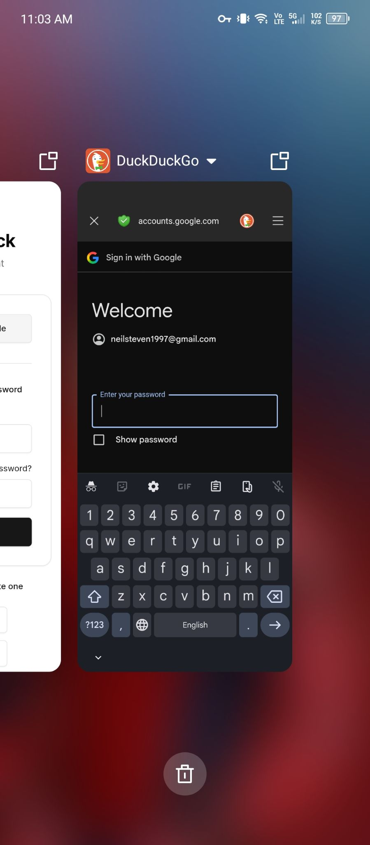
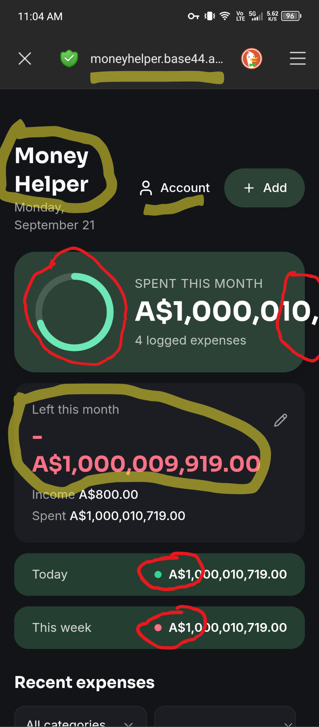
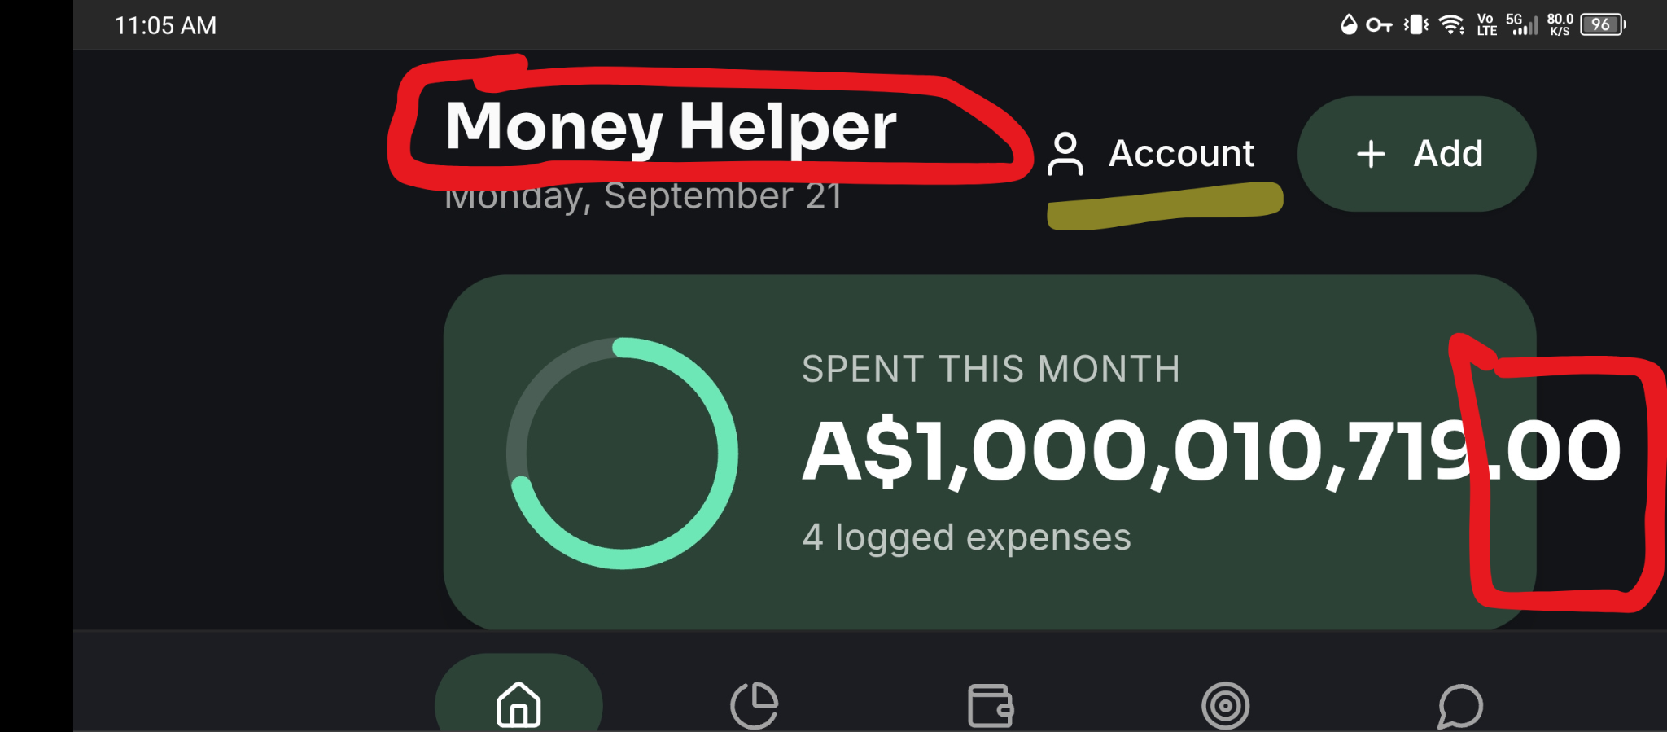

Expenses List
- Filter by date (put date today as default filter than empty)
- Fix the spacings
- (item names are not visible, the money overlaps - it needs overflow feature)
Overflow feature allows texts to move next line without causing any overlap
- Reduce the space covered by buttons; edit and delete

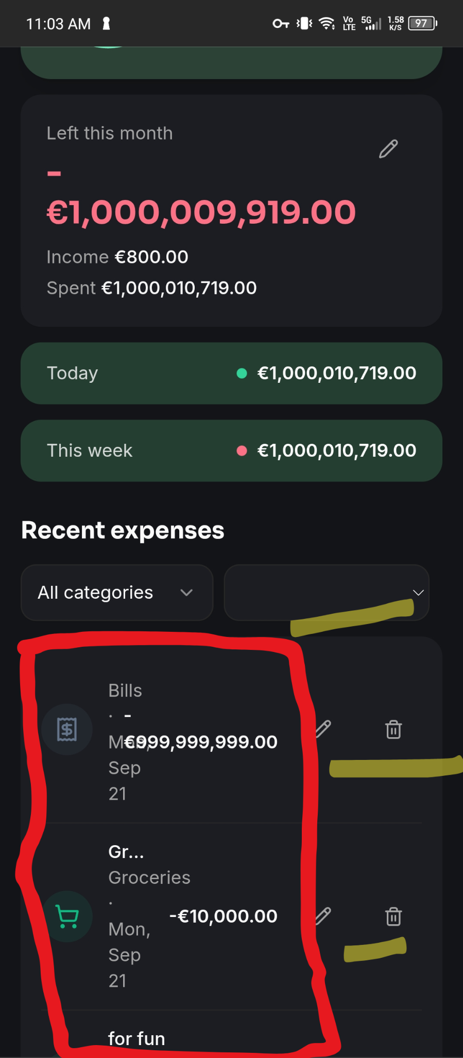

Promo Features
- Change the promo description, it sounds confusing, you can try: You can try everything out for free for the first 14 days, and after that trial period, you only have to pay a one-time fee of $3.99 to own the app.
- Change the button color for “Start free trial” to attractive green or #29DD22 and change the text color to white or #FFFFFF.
